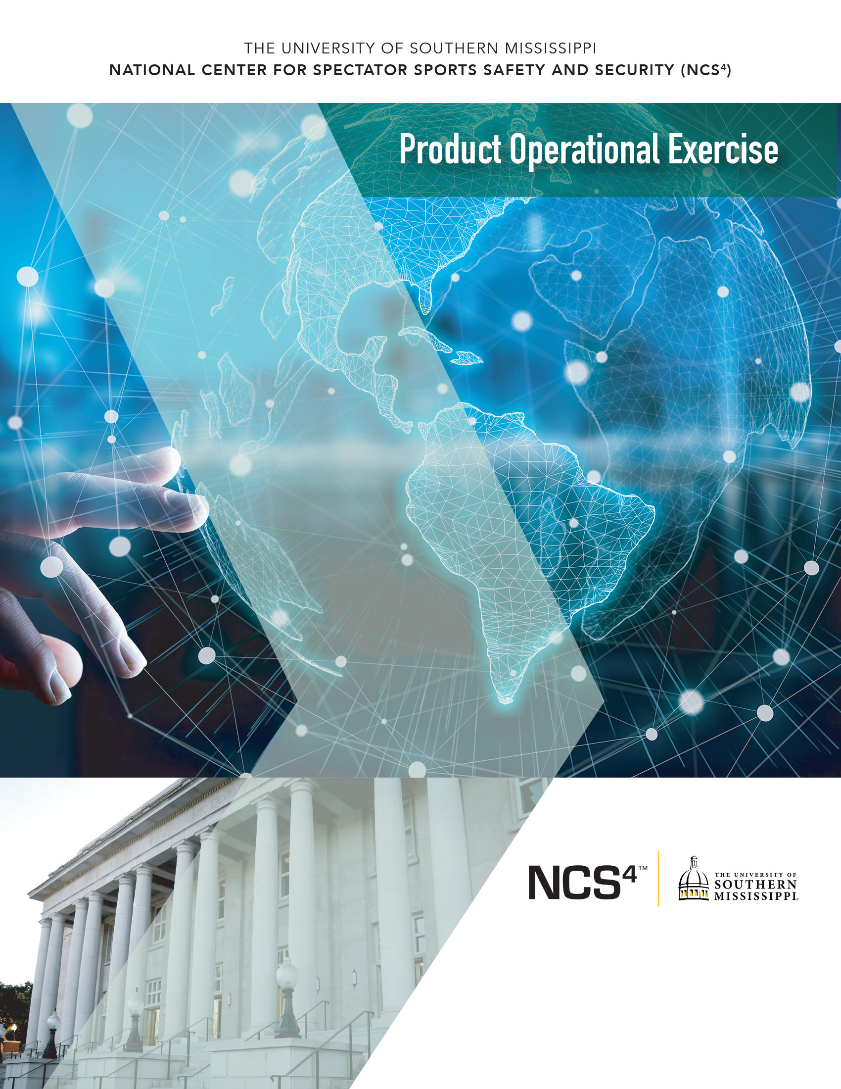
Evolv Technology
Evolv Express

Foreword

The National Center for Spectator Sports Safety and Security (NCS⁴) at The University of Southern Mississippi established the Operational Exercise Program to assist practitioners and industry experts in identifying operational use cases for safety and security solutions. By design, the demonstration and exercise allows sporting and venue experts to observe solution-provider-stated product capabilities in a real-world or simulated environment.

The NCS⁴ provides a mechanism to aggregate specific safety and security requirements for the spectator sports domain. The exercise process and focus areas were developed in cooperation with the NCS⁴ National Advisory Board, which includes representatives from professional sports leagues, select collegiate institutions, major events, and public assembly sites. The NCS⁴, using industry requirements and operational needs, partners with industry and technical experts to observe and exercise products or solutions with the intent to:

- Enable venue operators and security personnel to make informed decisions related to the selection and procurement of solutions.
- Observe and report a product’s ability to perform vendor-stated capabilities in a spectator sporting or special event environment.
- Ensure that technical promise translates to operational feasibility.
- Understand deployment and maintenance requirements.

The exercise program follows principles currently espoused by standing U.S. Department of Homeland Security (DHS) validation programs that are meant to assist end operators with objective and quantitative reviews of available commercial systems and solutions (e.g., Department of Homeland Security SAVER program).

Points of Contact

National Center for Spectator Sports Safety and Security
The University of Southern Mississippi
118 College Drive, #5193
Hattiesburg, MS 39406
https://www.ncs4.usm.edu/

Daniel Ward, CEM, MBA
Director of Training and Exercise
Phone: 601.266.5999
Email: daniel.l.ward@usm.edu

Joslyn Zale, PhD
Senior Research Associate
Phone: 601.266.6867
Email: joslyn.zale@usm.edu

Stacey Hall, PhD
Executive Director
Phone: 601.266.6308
Email: stacey.a.hall@usm.edu

Personnel

Exercise Evaluators

Evaluator 1
U.S. Secret Service Special Agent in Charge (Retired)

Evaluator 2
Security Representative for an organization that produces live events

Evaluator 3
Security Representative for professional baseball, soccer, and hockey

Vendor Support

Evolv Technology
500 Totten Pond Road 4th floor
Waltham, MA 02451 USA
+1 (781) 374-8100
https://www.evolvtechnology.com/

Richard Abraham, Vice President, Technical Sales & Solutions
Rudy Benitez, Solutions Engineer

Facilitators

Daniel Ward, CEM, MBA
Director of Training and Exercise, NCS⁴

Joslyn Zale, PhD
Senior Research Associate and CSSP Manager, NCS⁴

Table of Contents
Foreword 2
Points of Contact 3
Personnel 4
1. Introduction 6
1.1. Needs Analysis 6
1.2. Evolv Express Platform/Technology Overview 6
1.2.1. System Overview 7
1.2.2. System Software, Security, and Connectivity 9
1.2.3. Analytics for Proactive Planning 10
1.2.4. Remote System Management 14
1.2.5. ConOps Support and Training 15
1.2.6. Proven, Real-World Results 18
2. White Paper Objectives 19
3. Methodology 20
3.1. Overview 20
3.2. Exercise Team Selection and Training 21
3.3. Evolv Express Methodology 22
3.3.1. Exercise Location 22
3.3.2. Sensitivity Settings 24
3.3.3. Test Objects 25
3.3.4. Throughput 29
3.3.5. Exercise Evaluator Ratings 29
4. Results and Recommendations 31
5. Exercise Evaluator Overall Comments 40
5.1. Evaluator 1 40
5.2. Evaluator 2 40
5.3. Evaluator 3 41
6. Operational Exercise Summary 42
Appendix A: Exercise Evaluator Raw Scores and Comments 43

1. Introduction

The Introduction describes the needs analysis forming the basis for this evaluation and also provides an overview of Evolv Express.

1.1. Needs Analysis

In December 2018, the NCS⁴ National Advisory Board and Technology Alliance identified effective and efficient venue security checkpoints as a major priority for sports safety and security. This technology is designed with the intent of quickly detecting potential weapons on ingressing fans, including those holding bags, thus decreasing the time required to search individuals and their belongings.

This report presents a summary of the exercise and demonstration of Evolv Express. The platform was observed for functionality and overall performance capabilities.

1.2. Evolv Express Platform/Technology Overview

For sporting events, concerts, and the large stadiums and arenas that host them, fast and seamless ingress with uncompromising physical security is paramount. Analog technologies like metal detectors, hand wands, and visual bag checks can amplify the very same challenges they purport to resolve. Traditional methods for weapons screening can negatively affect guest experience, fatigue guard resources with repetitive alarms, and add to security problems by introducing crowded soft target scenarios.

Evolv Express is designed to screen for weapon threats while fans, employees, and other visitors walk through the system at a comfortable pace. Using advanced sensors, artificial intelligence, and camera technologies, Evolv Express intends to distinguish weapons from common personal items containing metal. The goal is to reduce fatigue on security teams caused by the excess nuisance alarms experienced with other approaches.

With Evolv Express fans should not need to divest their personal belongings or bags, helping both to avoid unnecessary physical contact and to elevate the guest experience by accelerating the pace of visitors through security screening. To further support security teams, the technology visually pinpoints where on a person or in their bag a potential threat has been detected, focusing and streamlining the way security teams target and resolve issues.

This overview was provided by Evolv Technology. While all statements were not evaluated during the exercise, several statements serve as the basis for exercise criteria.

1.2.1. System Overview

Evolv Express consists of a system of two or three towers creating either one or two lanes, each wide enough for as many as two people to enter a venue together, side-by-side (Figures 1-2). The lane width is also wheelchair ADA compliant.
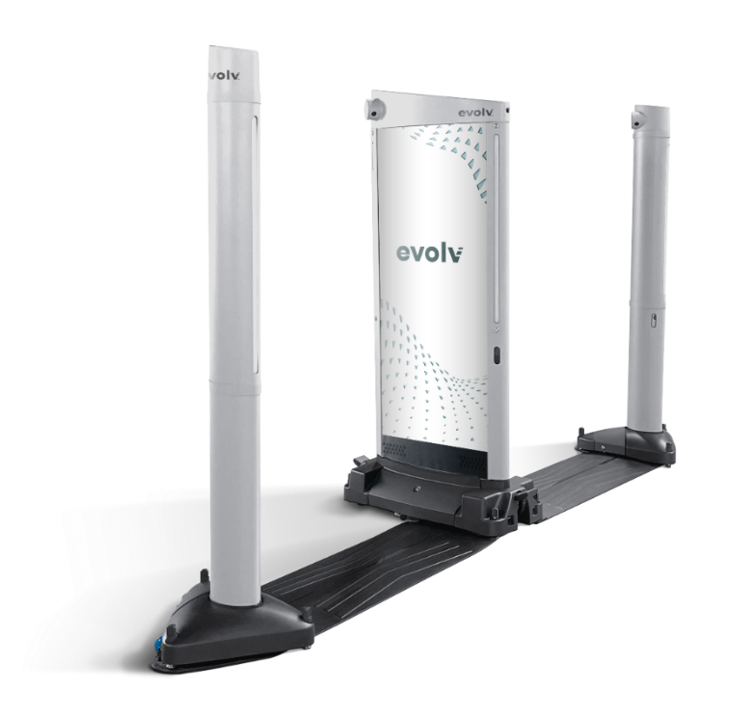
Figure 1. Evolv Express configured with three towers and two lanes

Figure 2. Evolv Express configured with three towers and two lanes

The system is designed to support venue ingress at a natural walking pace for families, screening an average of 3,600 people per hour at maximum capacity. Experience during live events at Evolv customer sites ranges from 2,700 to up to 4,500 people per hour—as much as one person per lane every 1.6 seconds. Throughput varies at each customer’s site based on their unique concept of operations (ConOps), security protocols, and other operational considerations.

The system is designed to be staffed by flow control and resolution personnel using up to three touchscreen tablets per lane to receive and review alerts. When the system alarms on an individual, each tablet receives images of the individual who alarmed the system, plus a red box superimposed on the image to indicate where on their person or in their bag the potential threat was detected (Figure 3).

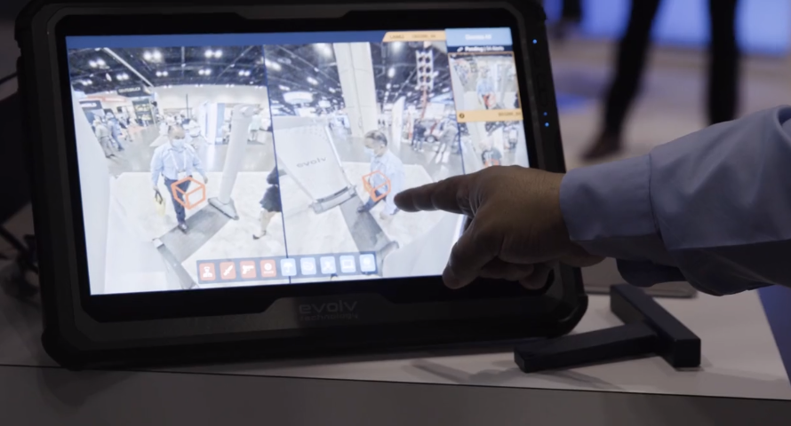
Figure 3. Tablet with red boxes superimposed over individuals who alarmed the system

When an alert appears, flow control personnel can divert the individual indicated in the alert to a resolution station, where the potential threat can be identified and resolved. This image-based resolution process supports both positive matching of the individual for flow control personnel and easy targeting of the location on their person or in their bag where the potential threat item was detected. This also accelerates and streamlines issue resolution for security staff by enabling a more targeted search process.

For maximum flexibility and set-up options, the system offers:

- Wired and wireless options for flow control and resolution tablets
- Indoor- and outdoor-equipped towers
- Mobility accessories to facilitate fast movement from storage to screening location and easy installation

This overview was provided by Evolv Technology. While all statements were not evaluated during the exercise, several statements serve as the basis for exercise criteria.

1.2.2. System Software, Security, and Connectivity

Security screening technology no longer has to be a standalone piece of equipment. It can offer communication and connectivity and digitally integrate with other venue technologies supporting security and operations. As a smart, connected weapons detection system, Evolv Express offers capabilities to integrate with other venue security technologies, communications, and protocols already in place. These capabilities include available integrations between the situational awareness cameras and customers’ existing video management systems, as well as a discreet “request for remote assistance” protocol that automatically texts assigned individuals to escalate the need for additional threat resolution support at a specific location in-the-moment (Figures 4-5).

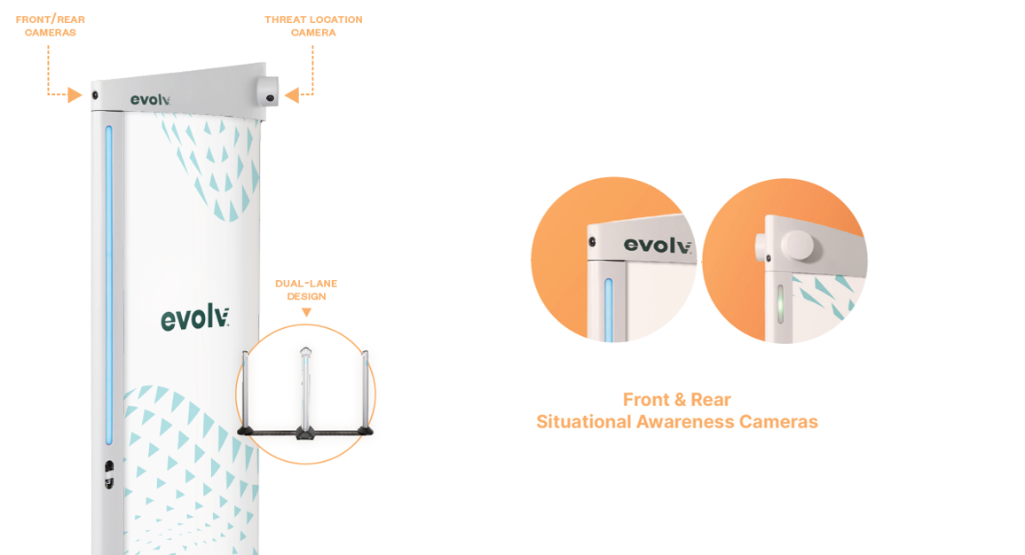
Figure 4. Optional front and rear situational awareness cameras, which can be integrated with existing video management systems

Visitor screening and camera technologies onboard the system respect the highest industry standards in data privacy and cybersecurity for venues and their guests. Communication and connectivity technologies rely on a fully hardened, built-in Wi-Fi system that does not require connection to the venue’s own network to operate. Visual alerts, including images of the person alarming the system, are set to automatically clear as soon as they are resolved by security teams.
Depending on the security and privacy policy at a venue, the system also offers the option to store alert data for further forensic analysis—a setting fully controlled by the customer.
Limited data—pertaining to visitor flow rates, alarm rates, threat types discovered, and operational logs for troubleshooting—is shared to a cloud platform to facilitate proactive planning and system health.

This overview was provided by Evolv Technology. While all statements were not evaluated during the exercise, several statements serve as the basis for exercise criteria.

1.2.3. Analytics for Proactive Planning

The Evolv Express system is capable of cloud connectivity to automatically capture data about visitor flow rates and alarm rates and communicate metrics to customers via a web-based or mobile application. This companion application, Evolv Insights, supplies business intelligence at the threshold of every venue. Evolv Insights enhances security planning, staffing, and operational decision-making.

In contrast with traditional approaches and manual screening methods, Evolv Express supports current and future security postures. Evolv Express produces data for pre-event planning and post-event analysis, as well as real-time ingress and alarm rate statistics during every event. Automatically generated reports can be sent following an event.

This overview was provided by Evolv Technology. While all statements were not evaluated during the exercise, several statements serve as the basis for exercise criteria.

1.2.4. Remote System Management

In addition to providing comprehensive analytics to improve venue security and operational decision making, the web-based and mobile-enabled Evolv Insights application also offers remote monitoring and management of Evolv Express systems.

For increased convenience and responsiveness, logging in to a specific system remotely from the MyEvolv app offers the same functions as when an administrator is co-located with the system.

This overview was provided by Evolv Technology. While all statements were not evaluated during the exercise, several statements serve as the basis for exercise criteria.

1.2.5. ConOps Support and Training

Evolv Express is offered in a Product as a Service/Software as a Service subscription model. Our team supports venues throughout ConOps planning, installation, system operation, and maintenance. Each installation is fully assessed and evaluated by security experts on staff both at Evolv and at the customer site, including (optionally) teams from our partner providers, to determine the best layout for installation and operation, including the locations, numbers and roles for security personnel in the flow control and issue resolution positions.

An example layout for peak flow (average of 3,600 visitors per hour) at one dual-lane Evolv Express system with two Flow Control tablets and two Alarm Resolution tablets is illustrated in Figure 12. Example staffing for a system installation like this one includes one supervisor role, four security staff plus two optional staff for peak operation, two greeters, and one law enforcement officer on an as-needed basis.

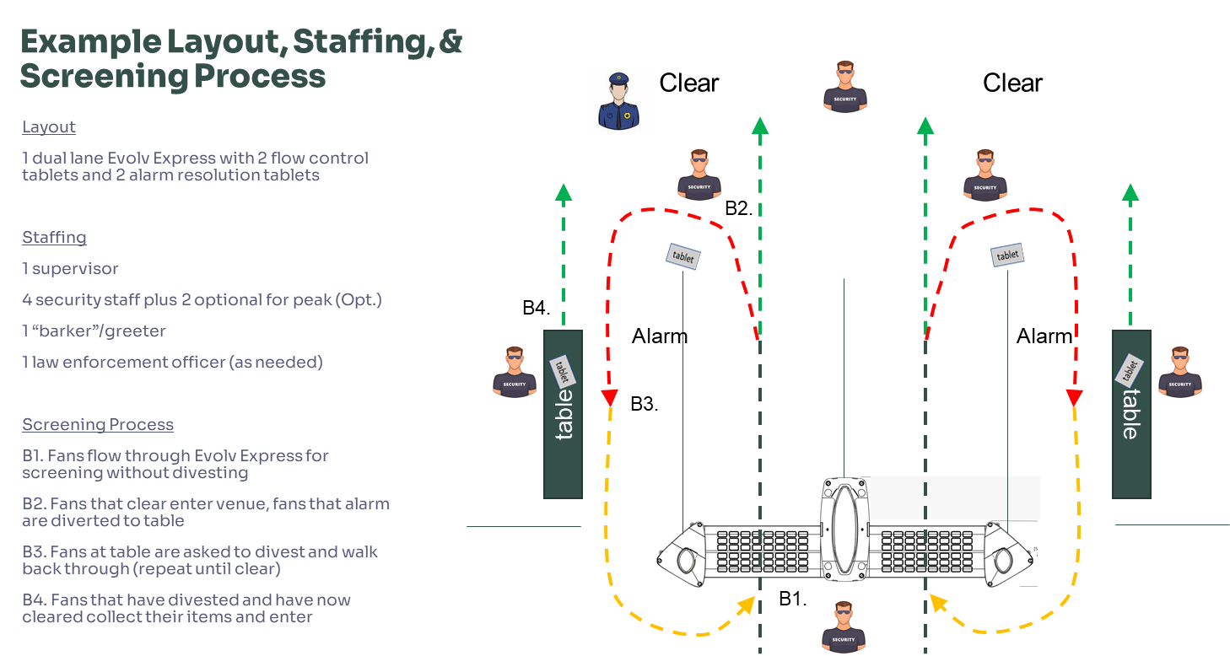
Figure 12. Example layout for a dual-lane Evolv Express system at peak operation – an average of 3,600 visitors per hour

Evolv security professionals partner with a customer’s venue security team to create a customized ConOps approach and system layout.

In addition to in-person training related to operation, installation, and maintenance—available at the customer’s site or at Evolv headquarters—Evolv also offers an always-on, no-cost subscription to its Learning Management System (LMS) for access to the same training material that is delivered in-person (Figures 13-14).

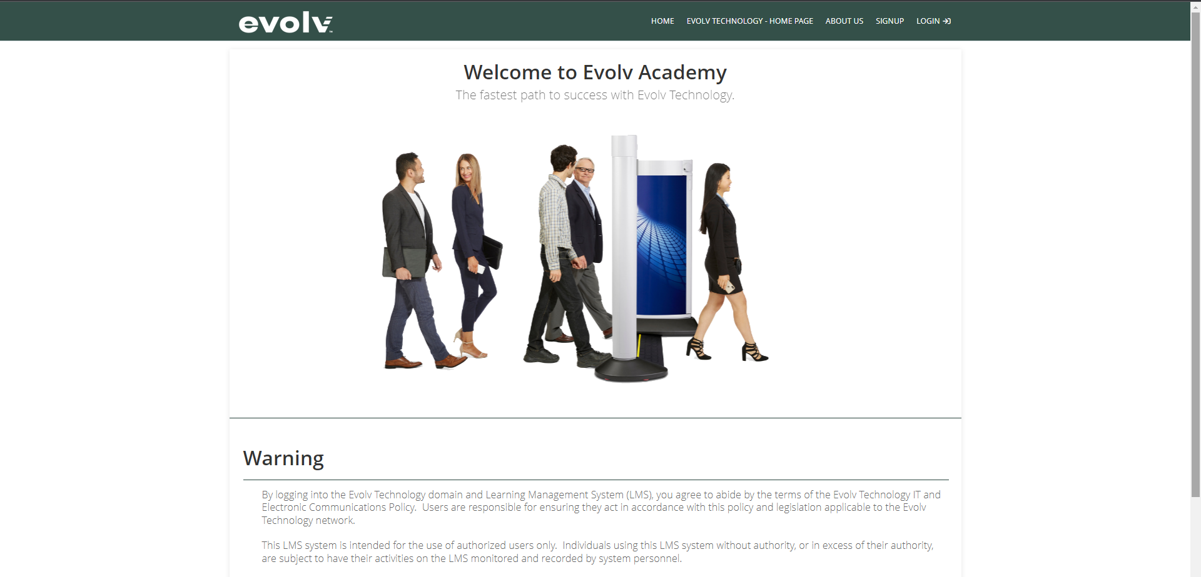
Figure 13. LMS log-in page

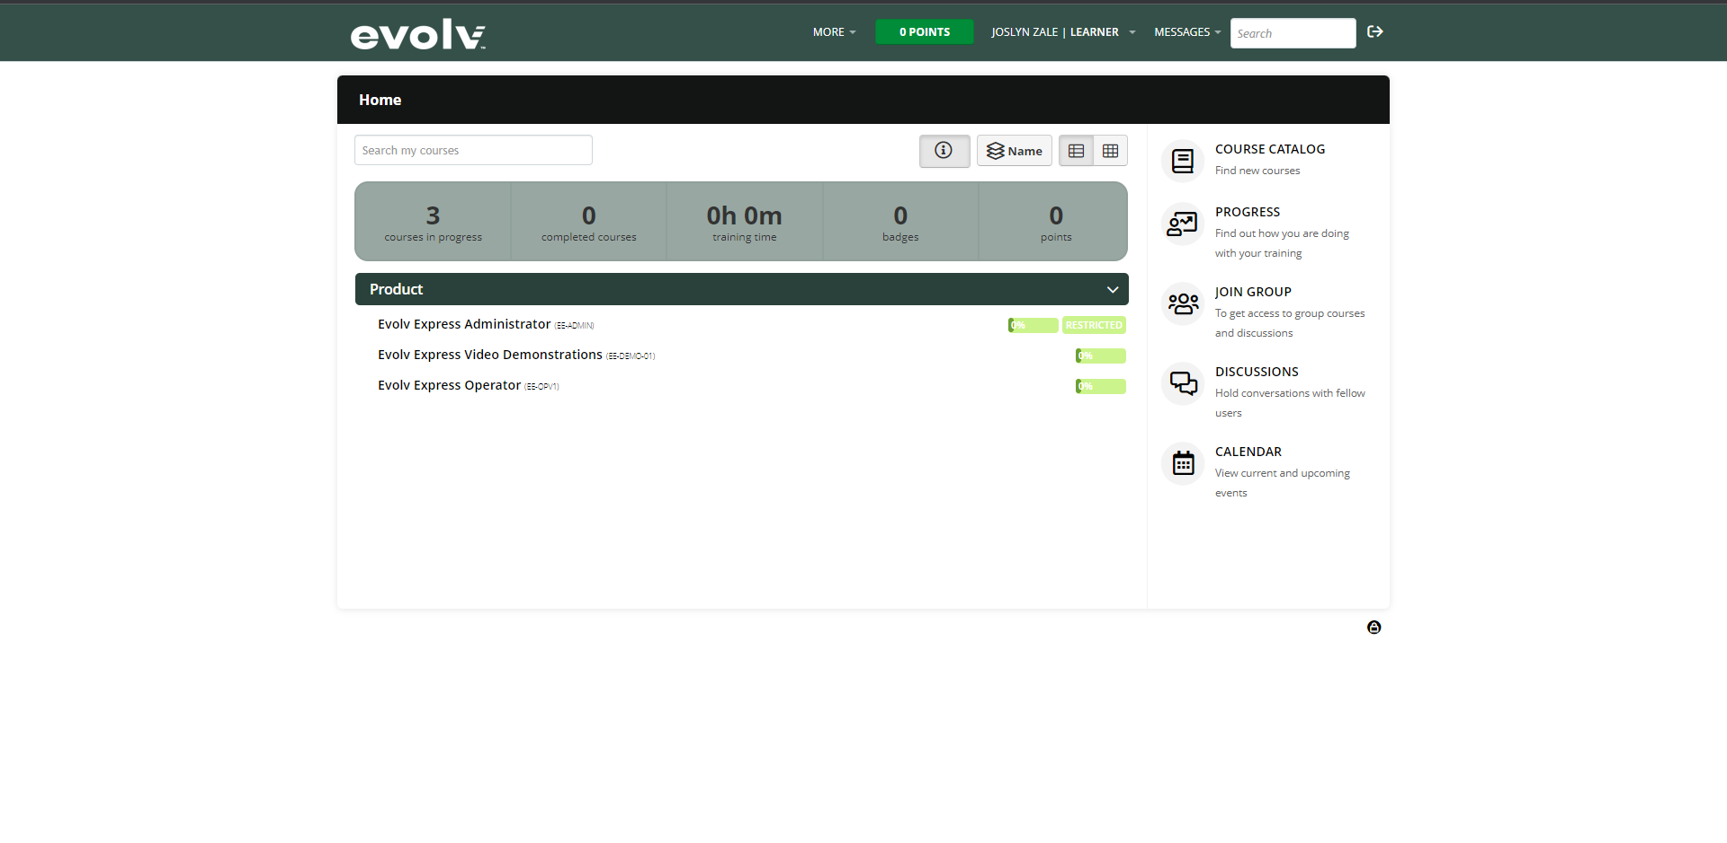
Figure 14. Three Evolv Express courses in the LMS

In addition to the LMS, a robust knowledge database is accessible to all customers through the web-based or mobile application, and handy electronic reference cards can be accessed on the system tablet for quick refreshers in set-up, operation, and troubleshooting. All of these resources are intended to support the customer on a day-to-date basis, along with access to 24/7 support from Evolv and its partner providers via phone or email.

This overview was provided by Evolv Technology. While all statements were not evaluated during the exercise, several statements serve as the basis for exercise criteria.

1.2.6. Proven, Real-World Results

In total, Evolv Express reportedly has screened over 150 million visitors at leading venues around the world, and counting. In the U.S., Evolv reports that their customers experience, on average, 70% lower labor costs and 10 times faster screening results versus walk-through metal detectors. Sports venues around the world using Evolv Express. At the time of this report multiple NFL, MLB, MLS, and other professional sports teams utilize Evolv Express to screen both fans and employees entering their venue.

By offering touchless weapons detection and efficient threat resolution, Evolv Express aims to elevate the fan experience and eliminate the lines that can create soft target scenarios, all without compromising the ability to prevent weapons capable of mass casualty events from entering venues. The goal is a significantly improved experience for fans and security staff while reducing the anxiety that traditional checkpoints create.

This overview was provided by Evolv Technology. While all statements were not evaluated during the exercise, several statements serve as the basis for exercise criteria.

2. White Paper Objectives

The objectives of this report are as follows:

- Describe the exercise methodology, scoring system, and the role of exercise evaluators.
- Outline the platform’s functional capabilities as identified by Evolv Technology.
- Publish the product operational exercise scoring results, comments, and additional information provided by the exercise evaluators and Evolv Technology.

The purpose of this exercise is to observe and report the demonstrated capabilities and functionalities of Evolv Express as indicated by Evolv Technology. This evaluation and/or report does not constitute NCS⁴’s endorsement of Evolv Express, nor is it intended to be used for comparison purposes with similar solutions.

3. Methodology

The NCS⁴ uses a scalable methodology to guide its product operational exercises. The methodology is designed to ensure that the exercise occurs in a realistic environment so that industry experts can observe whether the solution delivers the capabilities under the use case conditions (i.e., normal and/or emergency) within the ecosystem (i.e., sports, entertainment, and special event venue). The methodology includes: (1) a general overview of the steps used to perform an exercise, (2) the selection and training of exercise evaluators, and (3) how the aforementioned Steps 1 and 2 were applied to the exercise of Evolv Express.

3.1. Overview

A repeatable and scalable product operational exercise methodology was developed for use in the evaluation and assessment of numerous solutions. The methodology steps are as follows:

- The NCS⁴ and the solution provider seeking an operational exercise discuss the capabilities and functional requirements of the company’s solution and the professional backgrounds of three industry experts (e.g., law enforcement; fire/rescue emergency management; emergency medical; venue director of security, operations, or guest services) to participate as an exercise evaluator on the exercise team.

- The NCS⁴ ensures that the solution provider has access to the facilities and the means to create conditions for effectively demonstrating the capabilities and functional requirements of the solution and access to exercise evaluators with the requisite experience for observing the solution.

- The NCS⁴ and solution provider work together to create a matrix of operational capabilities and functional requirement items that the exercise team will quantitatively rate (described below in Section 3.2).

  - The company develops the items, and the NCS⁴ ensures that each item addresses only one capability or functional requirement.
  - Each item is written so that the exercise team, who may not be familiar with the solution, will understand the solution and the operational capability being observed in each item.
  - The NCS⁴ does not dictate what items they must include on the matrix but will share industry best practices, standards, and needs to ensure exercise criteria are developed with consideration to operational settings and capability gaps.

- The NCS⁴ and the company select a date(s), location(s), and use case(s) that will provide an appropriate ecosystem and the desired use case conditions for the product exercise.

- The NCS⁴ staff, company representatives, and the exercise evaluators meet at the date(s), location(s), and use case(s) as determined in Step 4. The NCS⁴ staff facilitates the exercise, ensuring that it adheres to an approved agenda. After all personnel introduces themselves, the company provides an overview of their organization and solution. To rate each matrix item, the exercise team either interacts with the solution themselves or closely observes company representatives, practitioners, or exercise role players interacting with the solution.

- After concluding the exercise, the NCS⁴ staff compiles evaluation forms and individual feedback from each exercise team member. The NCS⁴ staff uses quantitative feedback to create a cumulative matrix, calculating score averages for final scoring. The NCS⁴ staff uses qualitative feedback to provide score justifications and exercise team member comments.

Throughout the exercise, the exercise evaluators may ask the company representatives clarification questions about the operation and capabilities of the solution. The exercise evaluators may provide comments and/or answer questions from the company representative (e.g., potential use cases, cost, pricing plans, future capabilities that would be beneficial to add to the solution) and make recommendations and/or suggestions based on their professional experiences. Similarly, the company representatives may ask the exercise evaluators questions that may or may not be related to the matrix items. This open dialogue often yields valuable information beyond the matrix ratings.

3.2. Exercise Team Selection and Training

To maintain the impartiality of the exercise, the company may not request specific industry experts to serve on the exercise evaluation team. Per Step 1 in Section 3.1, the company may identify desired skills and experiences that observers should have for the exercise. The company may request discrete skills or general competencies relevant to the solution. The company may also identify the caliber of exercise team members based on experience, roles, or responsibilities. Per the information provided by the company, the NCS⁴ canvasses its sports safety and security industry network and its exercise database to identify potential exercise team members with the requisite professional backgrounds. The NCS⁴ will then invite qualified candidates to participate in the exercise until the NCS⁴ has secured a minimum of three exercise evaluators with the requisite expertise to serve as exercise team members.

As part of its due diligence, the NCS⁴ informs the exercise team members about the company and solution undergoing a product exercise during the team solicitation process so that potential exercise team members can assess their suitability and comfort level with the solution and identify any potential conflicts of interest. In some cases, individuals may decline due to a conflict of interest. If this occurs, the NCS⁴ will invite another qualified candidate to serve. Once exercise team members are confirmed, the NCS⁴ notifies the company who the team members are for the exercise.

Prior to the start of the exercise, the NCS⁴ facilitators train the exercise team members on the exercise process and review the item rating scale (Table 1). The NCS⁴ facilitators emphasize that each exercise team member will receive a copy of the matrix and rate each item individually using this scale; team members must each provide their own score and may not collaborate to develop a group rating for each item or the overall exercise. Team members are also encouraged to ask the company representatives questions and provide comments beyond the matrix rating feedback.

The company representatives are encouraged to ask the exercise team members questions related to, or outside the scope of, the matrix items. This dialogue, coupled with the matrix item ratings, provides complete exercise information. The matrix ratings show that the solution has been impartially rated by exercise team members against company-defined specifications, and the conversation allows for feedback beyond the scope of the matrix (i.e., for aspects of the solution that cannot be evaluated via a matrix, such as plans for future development or how to price and market the solution).

Table 1. Item Rating Scale
Score | Description
0 | Does not meet the stated requirement
1 | Partially meets the stated requirement
2 | Meets the stated requirement with recommendations
3 | Meets the stated requirement

3.3. Evolv Express Methodology

When applying the previously outlined methodology to Evolv Express, the industry experts were: (1) a U.S. Secret Service Special Agent in Charge (Retired), (2) a Security Representative for an organization that produces live events, and (3) Security Representative for professional baseball, soccer, and hockey. Exercise team members will be referenced by the aforementioned numbers throughout the rest of this document.

3.3.1. Exercise Location

The Evolv Express evaluation occurred on October 27, 2021, from 5:30-11 p.m. CDT at the southeast gate of Lower.com Field in Columbus, OH, USA for a Columbus Crew versus Orlando City soccer match (Figures 15-17).

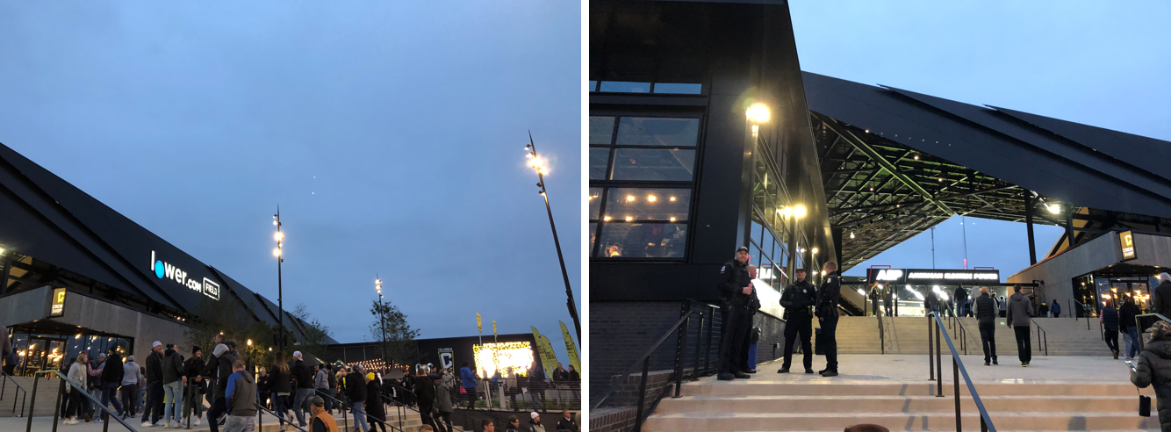
Figure 15. Southeast gate of Lower.com Field

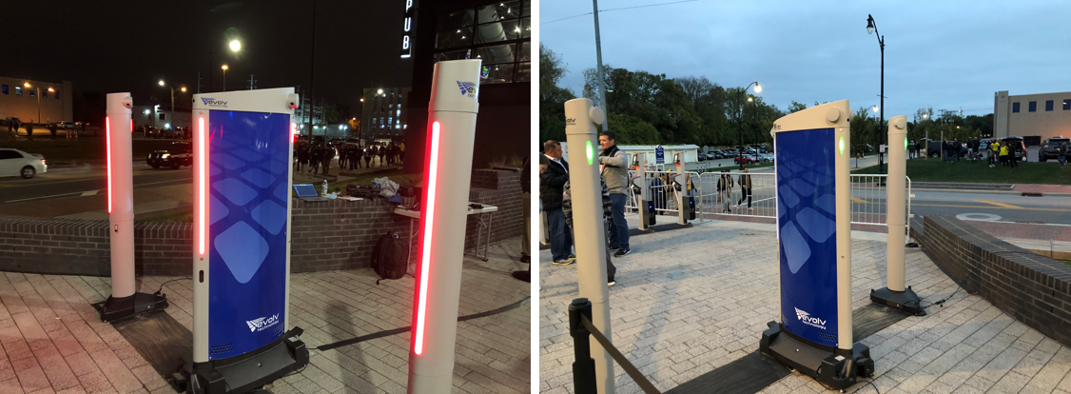
Figure 16. Evolv Express at the southeast gate of Lower.com Field

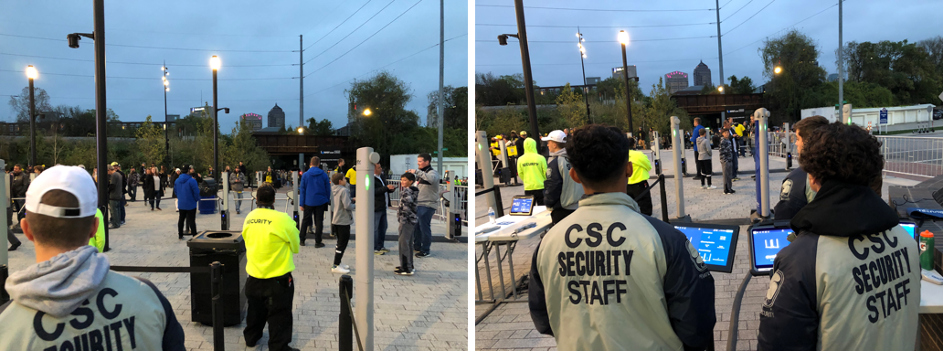
Figure 17. Security staff monitoring ingress through Evolv Express at the southeast gate of Lower.com Field

At 5:30 pm CDT, the weather conditions were an actual temperature of 48 °F, which felt like 50 °F, cloudy skies, wind gusts of 7 mph, 77% humidity, and a barometric pressure of 29.93 inches. Sunset was 6:37 p.m. CDT.

3.3.2. Sensitivity Settings

NCS⁴ facilitators performed tests on Evolv Express based on by NILECJ-STD-0601.00 (Table 2). The sensitivity level of Evolv Express is adjustable and was set at a level that is common for sports and entertainment venues.

The patron ingress journey consisted of the following steps (Figure 18):

- Patrons were processed through ticketing prior to processing through Evolv Express.
- Patrons flowed through Evolv Express for screening without divesting.
- In absence of an alarm, patrons were permitted to enter the venue without further screening. If Evolv Express alarmed, patrons were directed to the secondary screening table to divest prior to walking back through the system.

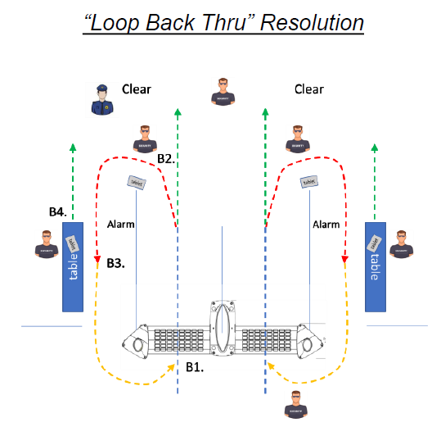
Figure 18. Patron ingress journey

3.3.3. Test Objects

Clean test subjects processed through the system at walking pace of 1.0 – 1.5 m/s, followed by test objects. Test objects were steel (UNS G41400) simulated handguns following the dimension criteria outlined in NILECJ-STD-0601.00 and NIJ Standard-0601.02 (Figure 19), firearms, firearm components, knives, and innocuous items (e.g., wrist watches and cell phones). The steel simulated handguns were positioned on clean test subjects and processed through the Evolv Express a total of 225 times while evenly distributed among the nine test locations identified in NIJ 0601.02. Figure 20 illustrates the nine test locations.

Figure 20. Diagram illustrating the nine test measurement locations

3.3.4. Throughput

Test subjects were screened walking through the portal at slow (0.5 m/s), normal (1.0 m/s), and fast (1.5 m/s) paces. Detection rates were not significantly influenced by walking speeds within these parameters during this observation.

During this observation, ticketing operations took place prior to patrons entering Evolv Express. The ticketing operations were unable to keep pace with the system. To estimate throughput capacity, the exercise evaluation team metered the amount of throughput in three separate five-minute increments when crowds had formed between ticketing and screening operations. The totals were averaged to estimate throughput capacity.

3.3.5. Exercise Evaluator Ratings

The average exercise evaluator rating for each matrix item was calculated using Equation 1:

$$Equation 1 R =\left(r{}_{1}+r_{2}+r_{3}\right) ÷e$$

where:
R = average exercise rating for a given matrix item
r₁ = Evaluator 1 rating for that matrix item
r₂ = Evaluator 2 rating for that matrix item
r₃ = Evaluator 3 rating for that matrix item
e = number of evaluators

Equation 1 was applied to each matrix item separately (e.g., the average evaluator rating was calculated for item 1.1, 1.2, 1.3, etc.).

The average evaluator score for all of the matrix items for each evaluator was calculated using Equation 2:
$$Equation 2 E= \left(\sum_{i=1}^{n}{r_{i}}\right)÷n$$
where:
E = average score for each evaluator for all matrix items
n = total number of items in the matrix
r = each evaluator’s rating for each matrix item

The overall average matrix rating (i.e., the average of all of the item scores from all three evaluators) was calculated using Equation 3:

$$Equation 3 A= \left(\sum_{i=1}^{n}{r_{1i}}+r_{2i}+r_{3i} \right) ÷ \left(n*e\right)$$
where:
A = overall average matrix rating
n = number of matrix items
r₁ = Evaluator 1 rating for each matrix item
r₂ = Evaluator 2 rating for each matrix item
r₃ = Evaluator 3 rating for each matrix item
e = number of evaluators

4. Results and Recommendations

This section covers the following matrix-related results: (1) the average individual matrix item rating from all of the exercise evaluators, (2) the average overall matrix score for each exercise evaluator, and (3) the average overall matrix rating.

The exercise evaluation team interacted with each capability outlined in the exercise criteria (Table 4). Additionally, these capabilities were observed while operated by event staff during event ingress.

Table 4 shows the function or categories evaluated by the evaluators. The specific details of each function or item evaluated, along with their rating can be found in the full report. Please contact Evolv Technology to gain access to this report.

Table 4. Matrix Item Average Exercise Evaluator Rating
Function # | Functional Area | Function/ Specification to Score
1 | Ferrous Metal Detection | Evaluated ability of Evolv Express to detect ferrous metals when concealed on a person. The test objects were steel (UNS G41400) simulated handguns following the dimensions criteria outlined in NILECJ-STD-0601.00 and NIJ Standard-0601.02, firearms, firearm components, knives, and other materials. | See full report for detailed results.
2 | Innocuous Item Test Objects | Evaluated ability of Evolv Express not to alarm on commonly carried items. | See full report for detailed results.
 |  |  | See full report for detailed results.
 |  |  | See full report for detailed results.
 |  |  | See full report for detailed results.
 |  |  | See full report for detailed results.
 |  |  | See full report for detailed results.
3 | Clutch Purse | Evaluated ability of Evolv Express not to alarm on a clutch purse. | See full report for detailed results.
4 | Bag | Evaluated ability of Evolv Express to detect threat objects in a bag. | See full report for detailed results.
5 | False Alerts | Evaluated that Evolv Express has a very low false alert rate for innocuous items (20% is the NIJ standard). | See full report for detailed results.
6 | Detection Rate | Evaluated that Evolv has a detection rate as defined in NILECJ 0601.00. | See full report for detailed results.
7 | Visual Indicator | Evaluated that Evolv Express has visual indicators to indicate normal operation and the detection of a potential threat. | See full report for detailed results.
8 | Audible Indicator | Evaluated that Evolv Express tablet is equipped with an audible alert as an additional notification for guards assigned to the lane. | See full report for detailed results.
9 | Multiple Objects | Evaluated that Evolv Express is able to detect two potential threats on the same person simultaneously. | See full report for detailed results.
10 | Multiple Object on Multiple People | Evaluated that Evolv Express is able to detect simultaneous alerts on multiple people at the same time in the same lane. | See full report for detailed results.
11 | Lane Throughput | Evaluated that a dual lane Evolv Express is capable of processing 3,600 or more people per hour or 1,800 people per lane per hour. | See full report for detailed results.
12 | Walkthrough Speed | Evaluated that Evolv Express will screen subjects walking through at a range of speeds including slow, normal, and fast as defined by NIJ 0601.02. | See full report for detailed results.
 |  |  | See full report for detailed results.
 |  |  | See full report for detailed results.
 |  |  | See full report for detailed results.
13 | Alerts and Flow Control Tablet | Evaluated that Evolv Express system is equipped with tablet to process alerts and to assist with threat resolution. | See full report for detailed results.
 |  |  | See full report for detailed results.
 |  |  | See full report for detailed results.
 |  |  | See full report for detailed results.
 |  |  | See full report for detailed results.
 |  |  | See full report for detailed results.
14 | Forensic Analysis | Evaluated that Evolv Express has ability to store screening results on internal computer. | See full report for detailed results.
15 | System Health/Self Diagnostics | Evaluated that Evolv Express, as part of the start-up process, performs self-diagnostics tests to determine if the system is ready to be used. The lights facing the operators will turn yellow to indicate the system is running a series of self- diagnostic tests. If the tests do not pass, the yellow lights will turn red. | See full report for detailed results.
16 | Remote Access | Evaluated that Evolv Express permits remote access to the system for service and troubleshooting purposes, and that administrator level access is required to access and modify settings. | See full report for detailed results.
 |  |  | See full report for detailed results.
 |  |  | See full report for detailed results.
17 | Statistics | Evaluated that Evolv Portal allows access to key visitors related data in near real-time and can be accessed at any point in the future. | See full report for detailed results.
18 | Analytics | Evaluated that Evolv Insights provides summary dashboards and insight analytics for every Evolv Express system. Additionally, that Evolv Insights automatically emails a report containing this information to registered users. | See full report for detailed results.
 |  |  | See full report for detailed results.
 |  |  | See full report for detailed results.
 |  |  | See full report for detailed results.
19 | Settings Visibility | Evaluated that Evolv Express allows Administrators to see the relevant settings from the wireless tablet. | See full report for detailed results.
20 | System Statistics | Evaluated that Evolv Express allows Users to see relevant statistics from the tablet. | See full report for detailed results.
21 | Threat Resolution Image | Evaluated that Evolv Express generates a threat resolution image for every alert. | See full report for detailed results.
21 | User Interface Indicators | Evaluated that Evolv Express sends error messages to the wireless tablet to indicate issues with the system. | See full report for detailed results.
 |  | Average Score | 2.82

Table 5 and Figure 24 show the average exercise evaluator score for the entire matrix (e.g., Function/Specification).

Table 5. Each Exercise Evaluator’s Average Matrix Score
Exercise Evaluator | Function/Specification
Evaluator 1 | 2.83
Evaluator 2 | 2.69
Evaluator 3 | 2.95

Figure 24. Average evaluator score for each evaluator

The overall average matrix score (i.e., the average of all item scores for all evaluators) was 2.82

Exercise evaluator scores and comments for each matrix item, as well as comments on the technology as a whole, are available in the full report.

5. Exercise Evaluator Overall Comments

The NCS⁴ asked each exercise team member to provide overall feedback relative to the solution following the operational exercise. Each exercise evaluator was given time to record the details of each demonstrated requirement. After reviewing their notes, team members were asked to provide a qualitative statement summarizing their thoughts on the product, which are available in the full report. Please contact Evolv Technology for access to the full report.

6. Operational Exercise Summary

The specific functions and features of this product were observed and rated by a team of industry experts as outlined in Section 3.2. The NCS⁴ staff facilitated the product operational exercise and compiled the results listed in this report. The NCS⁴ staff did not have any input into the scoring of the evaluation criteria or evaluator comments.

The overall composite score, 2.82 out of a possible 3.00, indicates that this product, on average, met the criteria used for this matrix. However, one function was rated below 2.0, indicating the functional area partially met the criteria used for this matrix. A summary of exercise evaluator ratings for the forty-two functions evaluated during this exercise is as follows:

Score | Description | # Functions
3 | Meets the stated requirement | 27
2 | Meets the stated requirement with recommendations | 14
1 | Partially meets the stated requirement | 1
0 | Does not meet the stated requirement | 0

Please note that exercise evaluator ratings are not intended to serve as a guide for procurement. Ratings are based on how well each evaluator determined the product performed its advertised capabilities. Customers should consider the risk tolerance, venue-specific needs, best practices, and policy when evaluating the appropriateness of this solution.

The NCS⁴ would like to thank the Columbus Crew, Columbus Police Department, industry experts and Evolv Express team for their participation in this operational exercise and commitment to creating a safer, more secure environment for spectators attending sporting and special events.

System Assessment and Validation for Emergency Responders (SAVER) Program. The SAVER Program conducts assessments and validations on commercial equipment and systems, and provides those results along with other relevant equipment information to the emergency responder community.

